**PCB terminology**

This section will provide a table of the most common terminology used in PCB design along with its definition or description. Know of the terminology is knowledgably when creating your printed circuit board. Also it helps when dealing with the Electronic Design Automation software that is used when creating the PCB.

**Table 1.1**

|  |  |
| --- | --- |
| **Terminology** | **Definition/Description** |
| Annular ring | The ring of copper around a plated through hole in a PCB |
| DRC | Design Rule Check. A software check of your design to make sure the design does not contain errors such as traces that incorrectly touch, traces too skinny, or drill holes that are too small. |
| Drill hit | Places on a design where a hole should be drilled, or where they actually were drilled on the board. |
| Finger | Exposed metal pads along the edge of a board, used to create a connection between two circuit boards. |
| Pad | A portion of exposed metal on the surface of a board to which a component is soldered. |
| Panel | A larger circuit board composed of many smaller boards which will be broken apart before use. |
| Plane (“pour”) | A continuous block of copper on a circuit board, define by borders rather than by a path. |
| Plated through hole | A hole on a board which has a annular ring and which is plated all the way through the board. May be a connection point for a through hole component, a via to pass a signal through, or a mounting hole. |
| Slot | Any hole in a board which is not round. Slots could be plated or might not be depending on the cost. |
| Surface mount | Construction method which allows components to be simply set on a board, not requiring that leads pass through holes in the board. |
| Thermal | A small trace used to connect a pad to a plan. If a pad is not thermally relieved it can create difficulty when trying to create a good solder joint, due to the pad not being able to get a high enough temperature. |
| Thieving | Hatching, gridlines, or dots of copper left in areas of a board where no plan nor traces exist. This reduced the difficulty of etching. |
| Trace | A continuous oath of copper on a circuit board. |
| V-score | A partial cut through a board, allowing the board to be easily snapped along a line. |
| Mouse bites | An alternative to V-score for separating boards from panels. Many of drill hits are clustered close together, creating a weak spot where the board can be broken easily after the fact. |
| Via | A hole in a board used to pass a signal from one layer to another. Vias where connectors and components are to be attached are often uncovered so that they can be easily soldered. |

**2 PCB software**

Electronic Design Automation (EDA) software is what is needed to design your PCB. Electronic Design Automation is a diverse category of software tools, including algorithms and applications. EDA is required for the design of Printed circuit boards, integrated circuits, semiconductors, and electronic products. There are a numerous amount of software packages that are able to help design your own printed circuit board. However, there are a few different types of software packages that are known and can be used to develop the design that you created and prototyped. To name some of the popular EDAs; Altium, Eagle, OrCad, DipTrace. This EDA software contains a schematic editor for the designing of your circuit diagram, so make sure to have the schematics already done before you start. This software allows back annotation of the schematic, and auto-routing to automatically connect traces due to the connection that you have based off of your schematic you have already completed. When deciding in which EDA software you want to use, you want to make sure that you consider 5 things. Functionality, usability, reliability, performance, and supportability. Most softwares are sort of pricey however, Altium, Egale, OrCad, and Dip Trace all off a free version of their software for non-commercial use. Yet with the free versions they do come with limitations like the amount of layers you are allowed to have with you printed circuit board. Below is a table of the different design software their prices and their limitations.

**Table 2.1**

|  |  |  |
| --- | --- | --- |
| **Software Package** | **Limitations/Specs** | **Price** |
| DipTrace Free Version | 2 layers, 500 pins | $0.00 |
| DipTrace Starter | 2 layers, 300 pins | $75 |
| DipTrace Standard | 4 layers, 1,000 pins | $345 |
| DipTrace Extended | 6 layers, 2,000 pins | $595 |
| DipTrace Full | None | $875 |
| Eagle Free Version | 16 layers, 4.0”X6.0” board | $0.00 |
| Eagle Standard | 6 single layers, 99 sheets | $820 |
| Eagle Professional | None | $1640 |
| OrCad Free Version | 2 layers, 100 pins | $0.00 |
| OrCad PCB Designer | None | $2,580 |
| Altium Designer | None | $7,245 |

The functionality and the ease of use of most of these EDA software’s is very difficult, however there are a lot of different outlets to help. Eagle is very difficult use, nonetheless, it is a very popular software that is used. Therefore there are a lot of tutorials online that you can. A lot of people have posted videos on how to use it as well. Also there are many articles that give you a guideline as to how to use it as well.

**2.1 PCB constraints**

When it comes to designing a PCB there are some constraints that come into account and need to be considered. For example; size, shape, thermal issues, track design, and some other factors that may affect the overall design of your PCB. The PCB is a very crucial component when it comes to an electronic system. Since ever PCB design is different and each may have a different layout than the next, this section list some of the constraints when designing, and some guidelines and what precautions to take when in the process of designing the PCB.

* Make sure that when choosing the reference points on your PCB that you do it so that it’s suitable for the manufacturer that you are using. Since each manufacturer is different they each may have a similar but slightly different process as to how they do things. You want to have reference holes or points on you circuit board, you just want to make sure that it is clear and not obscured for the text fixtures or the pick and place machines.
* Make sure that you have sufficient enough space on the board for the circuit. Make sure that you estimate the size of the board that you are going to need for your electrical system. You want to make sure that you have enough space to accommodate all the components that you are going to have on the board, also the tracks. Having the correct size is crucial, because you need to take into account the cost that the board will be when finished.
* When creating the printed circuit board you want know the amount of layers that you board is going to require. Again cost is a factor because depending on the software that you will be using the amount of layers you have the more the board will cost. Depending on the complexity of you design, the amount of layers you may need may be essential to because you may need to route them because of the amount of tracks your design has.
* Another thing to consider is the method of how you are going to mount you printed circuit board. Because depending on the way you may need to mount your board, you may need certain areas on your board to be free so you are able to mount it the way you need to. Again you want to determine this method before you start designing your board on the software, because you must take into account the cost if you mess up.

**2.1.1 Track design guidelines**

This section will give you a brief overview of some guidelines to take when it comes to the tracks and traces on the printed circuit board. When considering this part of the printed circuit board you want to know the specs early on before starting the designing process, so you have an idea of what you want. The table below shows the width of tracks and the different thicknesses of copper boards, with the corresponding current for that track width.

Table 2.1.1

|  |  |  |
| --- | --- | --- |
| Width of track for 1oz board (thousands) | Width of track for 2oz board  (thousands) | Current (Amps) |
| 10 | 5 | 1 |
| 20 | 15 | 2 |
| 50 | 25 | 3 |

The tracks that are currently used in the boards can only carry a limited amount of current through the track. Depending on the amount of current that needs to be carried through a trace; for example, a track that is connected to a power rail. Those types of traces and their widths need to be taken into considerations, since they would need to carry more current then a low level signal would need to carry.

* Establishing the standard track width you want to use in your printed circuit board design vital. Because the size of the traces does matter. If the tracks are too narrow, small and close together, then you have higher risk of having a short within your circuit. Alternatively, you also want to make sure that your traces aren’t too wide and far apart. Because this can take of space on the board, and if you don’t have enough space on the board for all your tracks then you would have to add more layers and that would cost extra.
* When first starting you design you want to know the ratio between the pad and the hole, but also the size as well. You want to make sure that the pad to hole ratio is sufficient enough so that way you have a good hole drilling tolerance. Depending on the manufacture you use for your printed circuit board, that manufacturer should provide the standards that are required for your pad and hole ratio. Since different manufacturers have a different process of how they may handle it. This ratio becomes particularly important when the size of the hole and the pad become smaller and smaller, because the accuracy needs to be exact otherwise you could risk messing up the board, and that will cost money. Via holes are important as well when the size of the hole and pad reduce.
* Another important aspect that needs to consider are the shape of the pads. All of the EDA software systems will have component libraries that will consist of schematics and PCB footprints for different components. Again depending on the manufacturer that you are using for your printed circuit design, these libraries can vary with the amount of component schematics or footprints that they have. The size of the pads are essential because they need to be large enough so that you are able to do wave and reflow soldering. Be contingent on who your manufacturer is so that way you have the correct size pads.

**2.1.2 Thermal issues**

Another aspect that may need to be consider is the thermal issue the circuit may have. Depending on the size of your circuit board you may or may not have to deal with this issue. For small printed circuit boards the thermal issue doesn’t really present a problem, so if you design is small that’s a constraint that you don’t have to worry about. However, if the design that you have is larger and preforms high component densities and processing speeds, then thermal issues would be a constraint that would need to be taken into consideration. When dealing with thermal issue you want to make sure that you have enough cooling going on for all of the components that you have. Components that dissipate great amounts of heat need to be cooled down accordingly. Also make sure to give those components that give off that large amount of heat more space on the board. If heat sinks are needed, make sure to provide enough space for that as well.

**2.2 PCB Layout Steps**

This section will give you guidelines and steps to help you when making you printed circuit board. Since the PCB is a critical part of any electronic system you want to make sure that you do it correctly, and make it reliable and long lasting for whatever electronic system you need it for.

**Step #1: set up initial settings**

This step is setting up the snap and visible grid, and you should be establishing the size of the traces and also the size of the pads, and set them as well. You also want to import the outline and details of your printed circuit board design that you have. You also want to establish the reference point and holes for the pick and place machines and text fixtures. So the manufacturer know for the production process of your printed circuit board.

**Step #2: put all components onto the board**

At this part of the process of creating the layout of your printed circuit board you want to place the components that are going to be used onto the printed circuit board. This is so that they will be available to use and place when you are configuring your design. Once you have the components on the layout, you then want to place them in their functional blocks. This helps to route the circuit easier and neighboring components are already close to each other.

**Step #3 identify and route layout critical tracks**

 Identify and traces that are critical and the route them as they are required. This is a good method to use because routing these first allows you to work around. This will avoid any problems you would have encountered on the PCB layout.

**Step #4 route power and earth rails**

Depending on the software, earth rails and power rails, may or may not be included as planes that could be occupying a complete layer on the printed circuit board. If you do find the earth rails and power rails occupying a complete layer it adds as an advantage, because it allows you to route the higher levels of current easily. Additionally it would also decrease any issues you may have faced with the interface on the printed circuit boards.

**Step #5 route remaining lines**

For this step you could use the auto route function that is provided in the software. This will say you trouble and a lot of time from doing the routing manually. However if you want to do the routing manually you can. When using the auto-route it is possible to set up parameters so that the software route it accordingly.

**Step #6 manually route any final lines on the PCB layout**

Once the auto-routing is complete, anything that has be done due to some trouble the system may have had with it, can be routed manually. However, if the design may be too complex for the space and also the amount of layers provided, you may want to consider some changes to the printed circuit board design.

**Step #7 undertake and complete a design rule check**

While all the design rules may have been followed it is good to do a final check so you can catch any problems or mistakes made. Because once prototype has begun it would be too late, and you would have to spend more money than what was actually needed.

**Step #8 have the work checked by and independent party**

It is also good to get a second look at your work by someone else, because they may catch an error that you may have missed. Having someone else check your work is also good practice as well.

**Step #9 release the design for prototype PCB manufacture**

Now that the PCB layout is complete and has been checked, you can now send it to the manufacturer so they can send it to get prototyped. You want to make sure that all the correct files that you have are sent. The files that you have should be released to the manufacturer to avoid any confusion. To avoid any unforeseen problems having a manufacturer of a prototype is a good thing to do. To the avoid the risk of extra cost to fixing problems.

**Battery Monitoring Circuit**

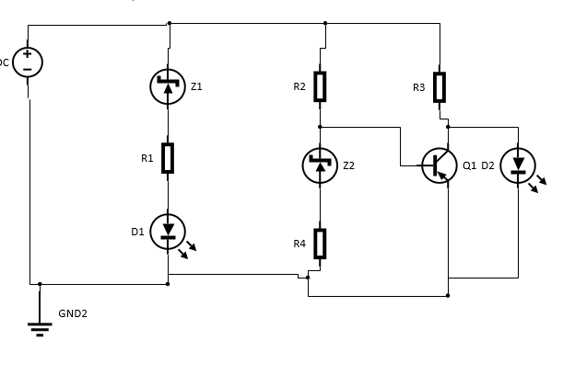

Figure 1

This schematic shows the circuit we will be using to monitor the amount of power is left in the batter. This will help us determine when the battery power is low and needs to be changed within each alarm system. This circuit is very simple and it is easy to implement as well. The only things that are needed to make it work are resistors, an NPN transistor, two Zener diodes, and you can use two separate LEDs, with one being green and one being red, or you can dues a Dual LED. The Zener diodes that are used are 5.6V, and determining on the voltage that the LEDs require, regulates the amount of the threshold voltage that will control the switching between the two LEDs that will then establish when the battery is low. The design is very simple, you have one Zener diode connected to the positive lead, which is then followed by a resistor and then followed by a LED that is then connected to the ground. This first part of the circuit dictates when the green LED is on and when it turns off. If the voltage supplied is above the threshold, then the green LED is lit, and this is due to the reverse bias of the Zener diode. This flow of current also goes through the Zener diode and flows into the base of the NPN transistor, which turns it on and prevents the red LED form turning on. When the power supplied is lower than the threshold voltage, then the current flow to the LED is prevented by the Zener diode. When the power supplied is below the preferred voltage then the flow of the current that was going into the base of the NPN transistor is no longer supplied, which turns off the transistors; in return the red LED will then switch on due to the current flowing to it. This is a nice simple design when it comes to monitoring the status of the battery, because the Zener diode along with the transistor at as a switch between the two LEDs. This switching factor is due to the breakdown voltage of the Zener along with the forward voltage of the LED; which in return establishes the switching voltage and the flow of current supplied to the transistor which will turn it on and off. This design is also very cost efficient since the components within this design are very accessible and cheap.

**Power supply**

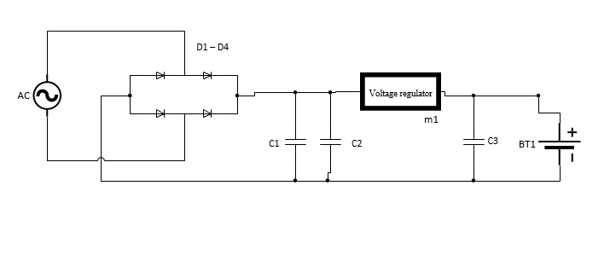

Figure 2

This schematic in the figure above shows the circuit of how our power supply will work. This schematic shows a Full Wave Bridge Rectifier Circuit, with smoothing capacitors and a voltage regulator. We chose to go with the full wave bridge rectifier circuit, because the full wave rectifier produces an output voltage that is purely DC. Also the full wave rectifier output has less ripple than the half wave rectifier, which produces a smoother output waveform. This design is more cost efficient, because it doesn’t require a centre tapped transformer. Also, the size of this rectifier design is much smaller without the transformer. The diodes are connected in bridge form and are in series pairs. This design allows for two diodes to be conducting during each half cycle. The bridge rectifier is then followed by a smoothing capacitance, this capacitance is what helps smooth out the full wave ripple output, and produces that purely smooth DC output voltage. When trying to find an acceptable smoothing capacitor you need to take into account the working voltage, and also the capacitance value. You want to make sure that the capacitance isn’t too low, otherwise it won’t a sufficient effect on the output waveform. However, if the capacitance is just large enough without the load current too big than it will have sufficient enough effect on the output waveform and create that smooth output voltage that would be pure like actually DC voltage. The block diagram below shows how the system will work.

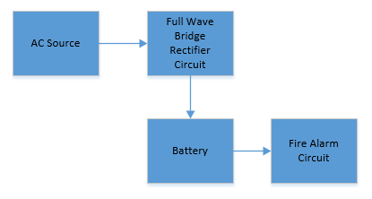

Figure 3

From the block diagram you can see that the fire alarm system is being powered by a battery. The AC power supply is actually charging the battery; while the AC source is still connected. Which in turn is supplying the power to the alarm system. This is where the Full Wave Bridge Rectifier Circuit comes into play. The Full Wave Bridge Rectifier Circuit takes the AC voltage source as the input and then outputs a DC voltage. Which then charges the battery while it supplies power to the fire alarm system. The Full Wave Bridge Rectifier Circuit is a critical part to the powering of the fire alarm system. This is because rectifier circuit is what is converting the AC voltage that is coming in and converting it to DC voltage which charges the battery while it is supplying power to the fire alarm system. The AC source in this design is the primary power supply source for this fire alarm system. While the battery is the secondary power supply for this system. The battery being charged throughout this time is crucial, because when the AC is cut off it won’t be supplying power to the alarm. This is because the bridge rectifier circuit is constructed out of diodes, and diodes rely on a voltage source to work sense they act like switches. So since if the AC source stops supply voltage to the circuit, then the diodes are not on and there is no current flow. So therefor, since there is no current flowing through the circuit, the batter doesn’t get charged. So now the fire alarm system is solely running off of the battery during this lapse of time that the AC power supply is not working. During the time that the primary power supply is unavailable; according to the National Fire Protection Association 72 code and standards, the secondary power supply must be able to last 24 hours and 15 minutes until the primary source of power comes back on. However, this is only the maximum amount of time that is provided by the NFPA code and standards.